Task 1:

**Connection Pooling:**

Connection Pooling is used to enhance the performance of executing commands on database and make the web applications perform much more efficiently. By reusing the connections through the caching of the connections, we are able to perform the database connections much faster and much more efficiently.

To use the Connection Pooling, we simply overrode the Connection made in the earlier projects. Also, we added the context.xml in the /WebContent/META-INF/context.xml file to add the following line:

<Context path="/project3">

<br/>

<lt;Resource name="jdbc/moviedb" auth="Container" type="javax.sql.DataSource"

initialSize="40" maxActive="100" maxIdle="80" minIdle="40” minEvictableIdleTimeMillis="55000" timeBetweenEvictionRunsMillis="34000"

testOnBorrow="true" validationInterval="60000" validationQuery="SELECT 1"

removeAbandoned="true" removeAbandonedTimeout="55" maxWait="10000"

username="mytestuser" password="mypassword” driverClassName="com.mysql.jdbc.Driver" url="jdbc:mysql://localhost:3306/moviedb?autoReconnect=true&amp;useSSL=

false&amp;cachePrepStmts=true" />

<br/>

</Context>

We also had to add the following code into the /WebContent/WEB-INF/web.xml before the servlet declarations:

<resource-ref>

<description>

Resource reference to a factory for java.sql.Connection

instances that may be used for talking to a particular

database that is configured in the server.xml file.

</description>

<res-ref-name>jdbc/moviedb</res-ref-name>

<res-type>javax.sql.DataSource</res-type>

<res-auth>Container</res-auth>

</resource-ref>

In addition, we had to import the following packages from the Java Library to allow the Connection Pooling in each of our Servlets:

import javax.naming.InitialContext;

import javax.naming.Context;

import javax.sql.DataSource;

add_movie.java: addstar.java

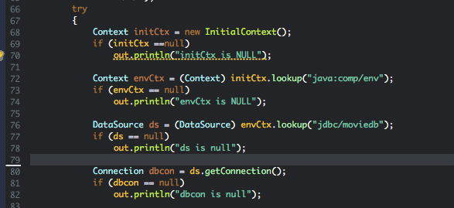 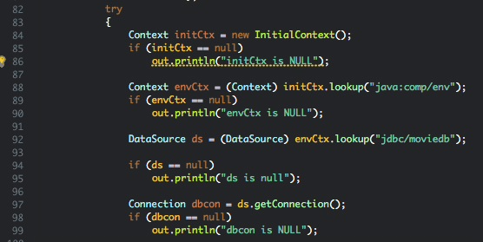

browsegenre.java checkccinfo.java

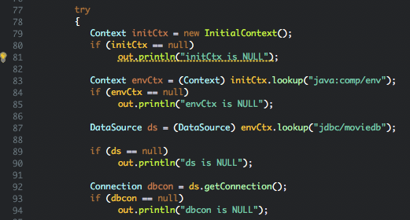 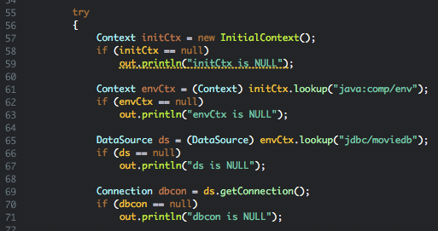

dLogin.java finalcheckout.java

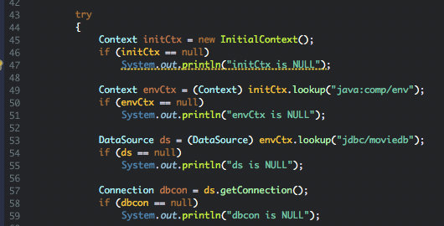 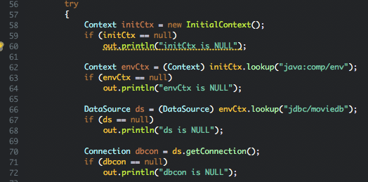

genresearch.java login.java

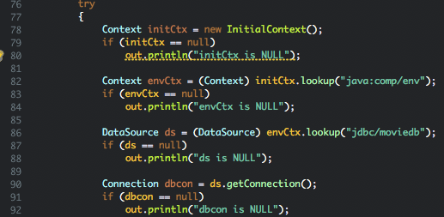 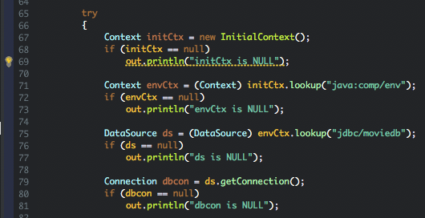

loginapp.java metadata.java

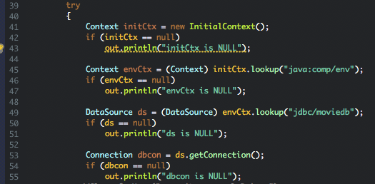 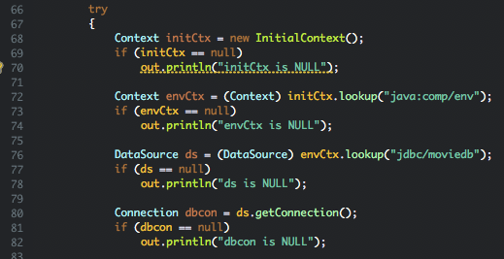

movie_suggestion.java movieinfo.java

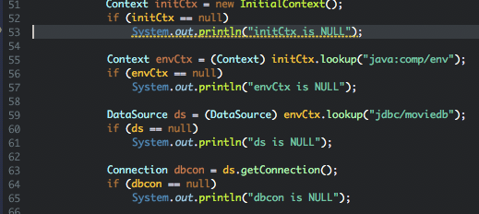 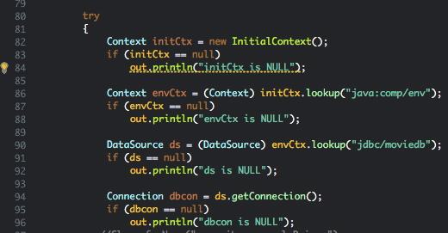

search_page_app.java searchpage.java

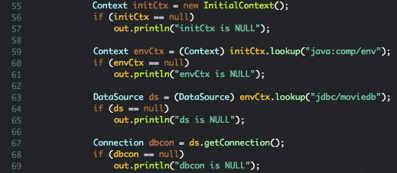 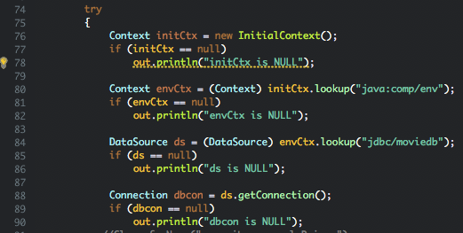

shoppingcart.java starinfo.java

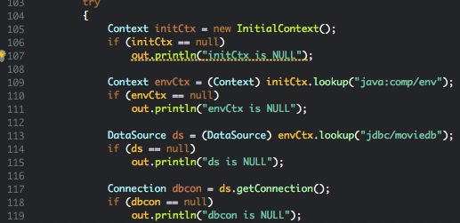 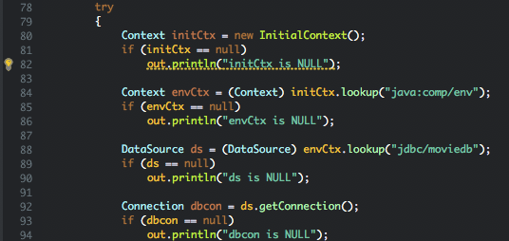

**Prepared Statements:**

To reduce the execution time of the SQL queries every time we log into the MySQL Server, we used the Prepared Statements. The main benefit of the PreparedStatement is that it sends the query to the DBMS right away where it is compiled.

We implemented this by adding the “import java.sql.PreparedStatement;” package to all the servlets that use the search method and implemented the following lines:

browsegenre.java checkccinfo.java

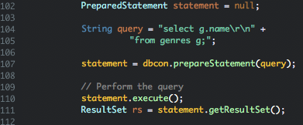 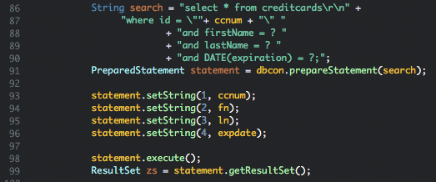

dLogin.java finalcheckout.java

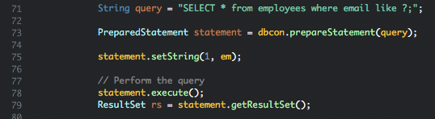 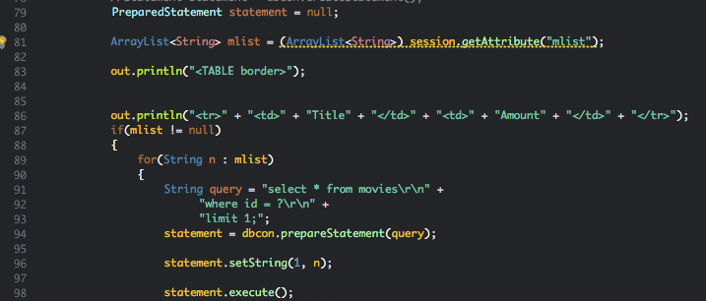

genresearch.java login.java

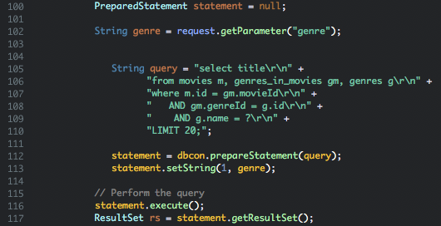 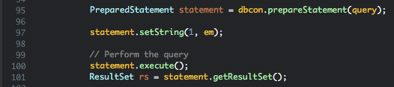

loginapp.java metadata.java

 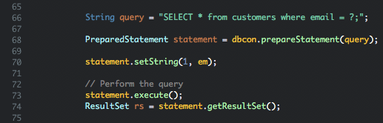

movieinfo.java search_page_app.java

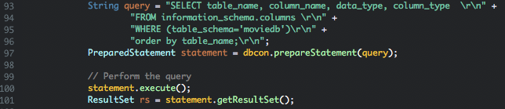 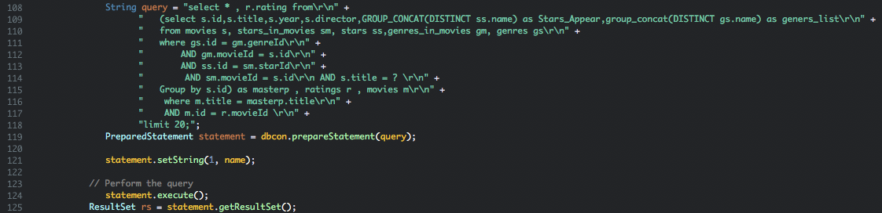

searchpage.java

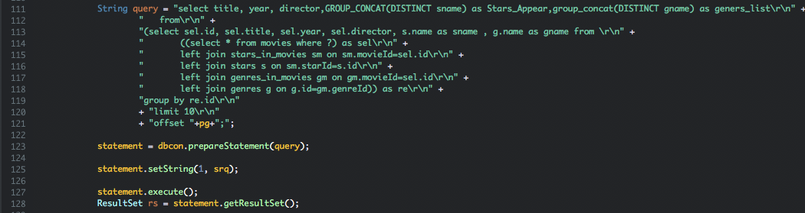

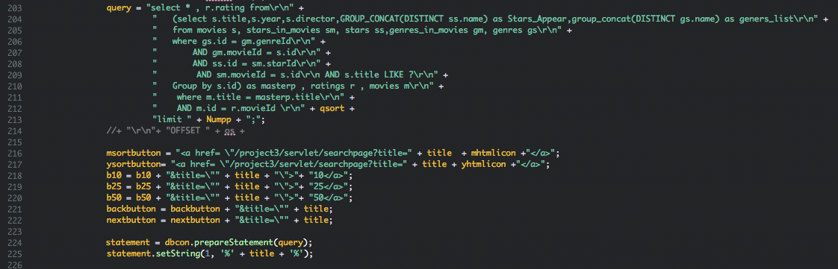

shoppingcart.java starinfo.java

